**Year 9 Chemistry**

**Structure of an Atom- Revision**

* Atoms are made of three subatomic particles: ____________, ________________ and ____________.
* Protons and neutrons are found in the centre of an atom, which is called the ____________.
* Electrons orbit the nucleus at very high speeds.
* Some subatomic particles have electrical   
  charges:
  + - **Protons** have a ________________(+)   
      charge
    - **Electrons** have a _______________ (-) charge
    - Neutrons are neutral and have __________________
* The number of protons in the nucleus of an atom determines which _____________ the atom is.
* All atoms of an element have the same number of _____________________.
* For example, all _________________ atoms have 6 protons.

This is referred to as the **atomic number** of the element.

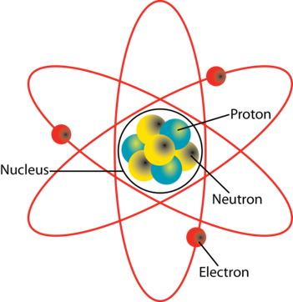

A neutral atom has the same number of _________________ as ___________________.

This means that the number of ____________ charges equals the number of _____________ charges.

The charges __________ each other, so the entire atom has ______ ______________.

For example, the atom in the picture has three positive protons and three negative electrons, so it has no overall charge.

|  |
| --- |
| Describing the Structure of an Atom |
| 1. State the number of protons and neutrons in the nucleus. 2. State the number of electrons orbiting the nucleus. 3. State whether the atom is neutral or charged.   neutral = number of protons and electrons is **equal**  charged = number of protons and electrons is **not equal** |

Describe the structure of the lithium atom (pictured above):

There are _____ protons and _____ neutrons in the nucleus.

There are _______ electrons orbiting the nucleus.

The atom is _____________ because ______________________________________________________________.

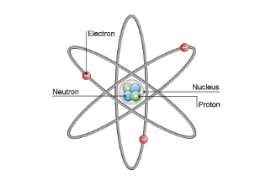Describe the structure of the Helium atom

There are _____ protons and _____ neutrons in the nucleus.

There are _______ electrons orbiting the nucleus.

The atom is _____________ because ______________________________________________________________.

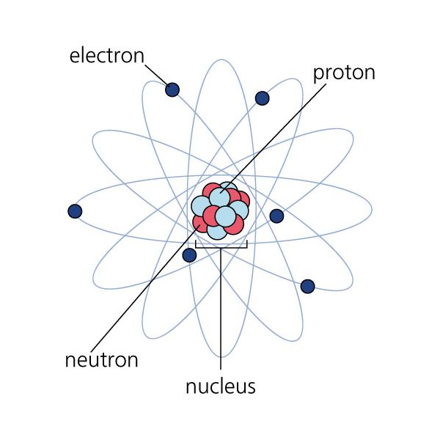Describe the structure of the Carbon atom.

There are ______ protons and _______ neutrons in the nucleus.

There are ________ electrons orbiting the nucleus.

The atom is _________________ because __________________________________________________________.

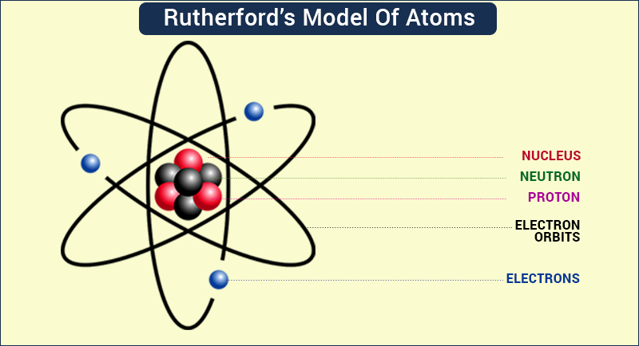Describe the structure of the Beryllium atom.

There are ______ protons and _______ neutrons in the nucleus.

There are ________ electrons orbiting the nucleus.

The atom is _________________ because __________________________________________________________.

Draw the and describe atomic structure of three different elements below